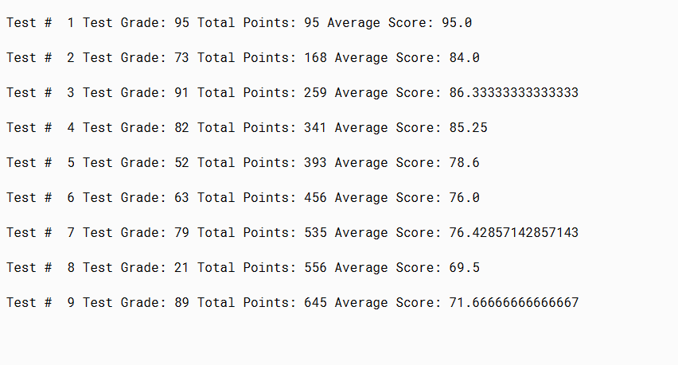

PMR: this project was overall simple and good practice. The only issue I had and had to refer to the binder was getting the average score, but I learned what to do, it required a double which I was coding wrong, but now I can learn from my mistakes!!

/\*\*

\* The purpose of the program is to calculate the grade point

\* average of a student

\*

\* @author Anika Jallipalli

\* @version 09/15/2019

\*/

public class AdmissionV1

{

public static void main(String[ ] args)

{

//local variables

int numTests = 0; //counts number of tests

int testGrade = 0; //individual test grade

int totalPoints = 0; //total points for all tests

double average = 0.0; //average grade

//Calculate total grade point average at test

testGrade = 95; // individual test grade

numTests++;

totalPoints+= testGrade;

average= (double)totalPoints / numTests;

System.out.println("");

System.out.print(" Test # " + numTests);

System.out.print(" Test Grade: " + testGrade);

System.out.print(" Total Points: " + totalPoints);

System.out.println(" Average Score: " + average);

//Calculate total grade point average at test

testGrade = 73; // individual test grade

numTests++;

totalPoints+= testGrade;

average= (double)totalPoints / numTests;

System.out.println("");

System.out.print(" Test # " + numTests);

System.out.print(" Test Grade: " + testGrade);

System.out.print(" Total Points: " + totalPoints);

System.out.println(" Average Score: " + average);

//Calculate total grade point average at test

testGrade = 91; // individual test grade

numTests++;

totalPoints+= testGrade;

average= (double)totalPoints / numTests;

System.out.println("");

System.out.print(" Test # " + numTests);

System.out.print(" Test Grade: " + testGrade);

System.out.print(" Total Points: " + totalPoints);

System.out.println(" Average Score: " + average);

//Calculate total grade point average at test

testGrade = 82; // individual test grade

numTests++;

totalPoints+= testGrade;

average= (double)totalPoints / numTests;

System.out.println("");

System.out.print(" Test # " + numTests);

System.out.print(" Test Grade: " + testGrade);

System.out.print(" Total Points: " + totalPoints);

System.out.println(" Average Score: " + average);

testGrade = 52; // individual test grade

numTests++;

totalPoints+= testGrade;

average= (double)totalPoints / numTests;

System.out.println("");

System.out.print(" Test # " + numTests);

System.out.print(" Test Grade: " + testGrade);

System.out.print(" Total Points: " + totalPoints);

System.out.println(" Average Score: " + average);

testGrade = 63; // individual test grade

numTests++;

totalPoints+= testGrade;

average= (double)totalPoints / numTests;

System.out.println("");

System.out.print(" Test # " + numTests);

System.out.print(" Test Grade: " + testGrade);

System.out.print(" Total Points: " + totalPoints);

System.out.println(" Average Score: " + average);

testGrade = 79; // individual test grade

numTests++;

totalPoints+= testGrade;

average= (double)totalPoints / numTests;

System.out.println("");

System.out.print(" Test # " + numTests);

System.out.print(" Test Grade: " + testGrade);

System.out.print(" Total Points: " + totalPoints);

System.out.println(" Average Score: " + average);

testGrade = 21; // individual test grade

numTests++;

totalPoints+= testGrade;

average= (double)totalPoints / numTests;

System.out.println("");

System.out.print(" Test # " + numTests);

System.out.print(" Test Grade: " + testGrade);

System.out.print(" Total Points: " + totalPoints);

System.out.println(" Average Score: " + average);

testGrade = 89; // individual test grade

numTests++;

totalPoints+= testGrade;

average= (double)totalPoints / numTests;

System.out.println("");

System.out.print(" Test # " + numTests);

System.out.print(" Test Grade: " + testGrade);

System.out.print(" Total Points: " + totalPoints);

System.out.println(" Average Score: " + average);

}//end of main method

}//end of class